Gapar Galym

SE-2418

Introduction
In these chapters, I worked on understanding Flutter widgets, building scrollable screens, and creating a more advanced responsive page for the app. These chapters helped me learn how Flutter UI is structured and how to make the app look better and work smoothly on different screen sizes.

Chapter 5, I started working with scrollable widgets, which are important when the content does not fit on a single screen. This helped me understand how to create flexible layouts.
I used the ListView widget to display items in a scrollable list, both vertically and horizontally. This allowed users to easily navigate through different sections of the app.
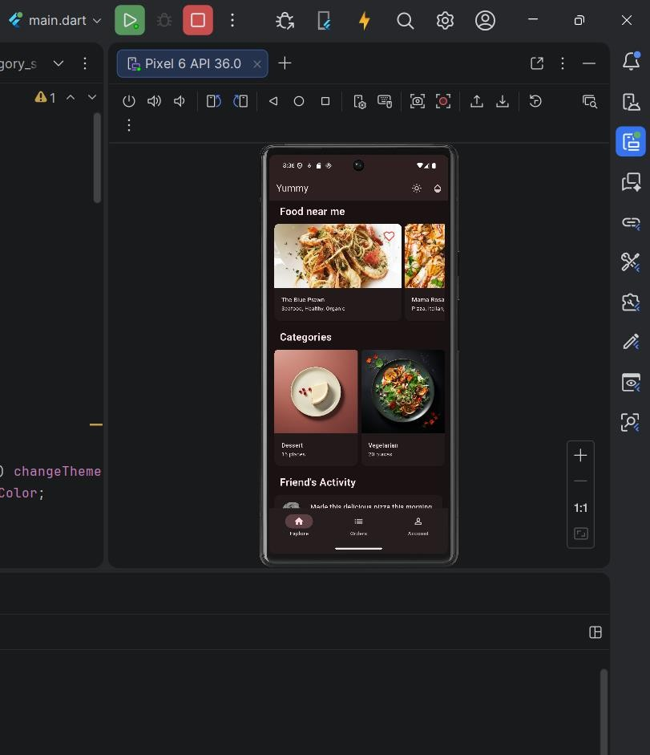
After that, I created the Explore screen, where I used FutureBuilder to load data asynchronously. This means that the app can fetch and display data without freezing the UI.
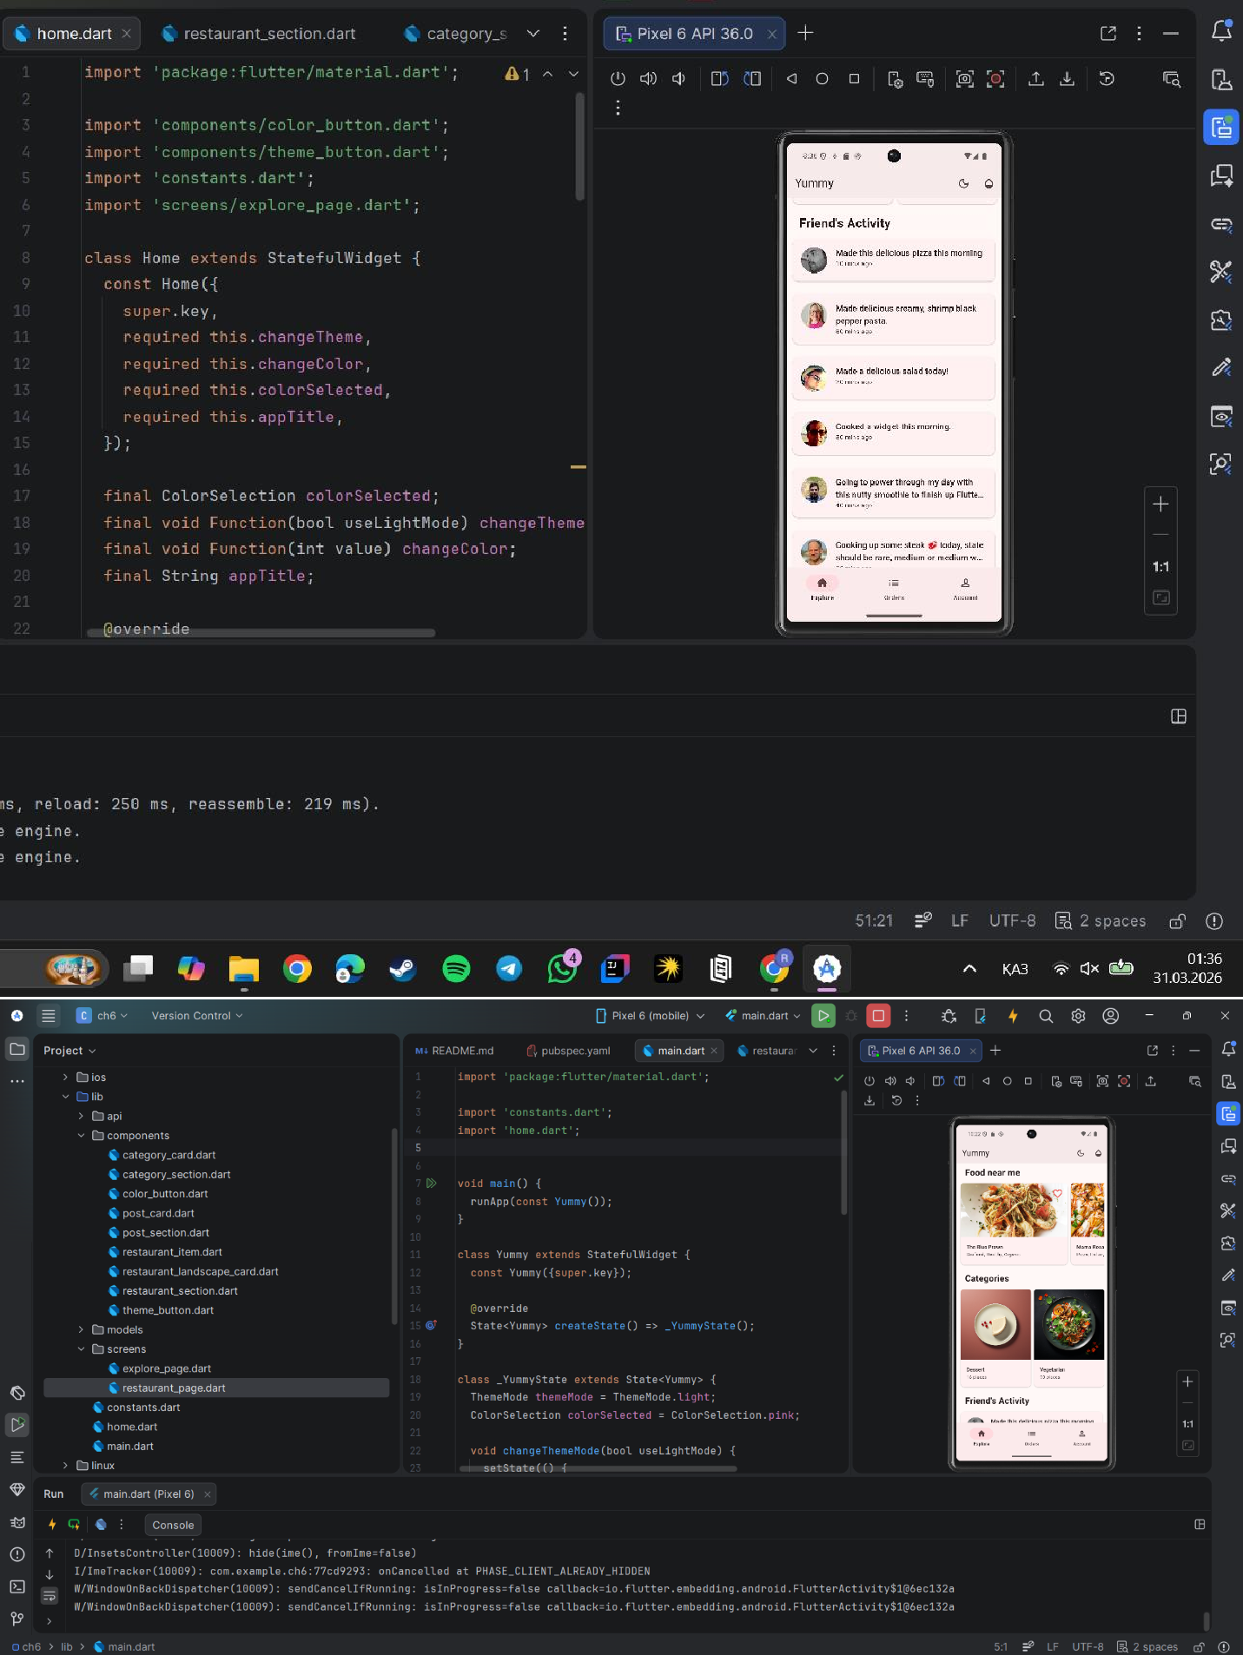
Then, I built different sections such as restaurants, categories, and posts. To achieve this, I combined multiple scrollable widgets, which helped me structure the content in a clean and organized way.
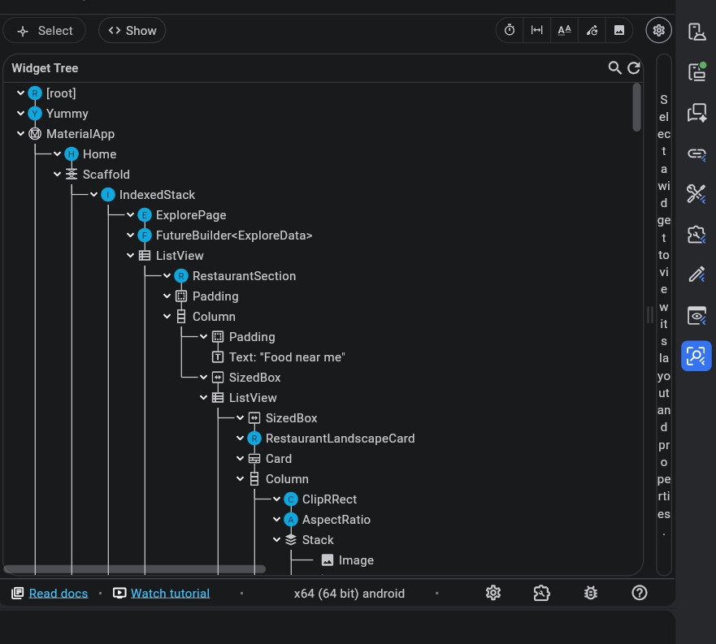
Finally, I learned that Flutter allows combining multiple scrollable elements in one screen, which gives more flexibility when designing complex user interfaces.
Chapter 6
In Chapter 6, I continued improving the application by creating a new RestaurantPage, where users can see detailed information about a restaurant and its menu.
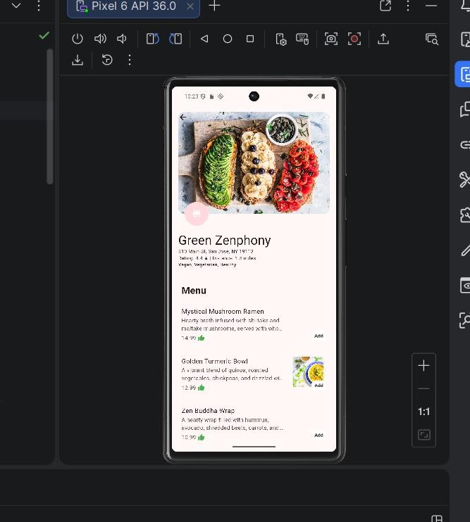
I added navigation, so when a user taps on a restaurant card, it opens the detailed restaurant page. This improved the interaction and user experience.
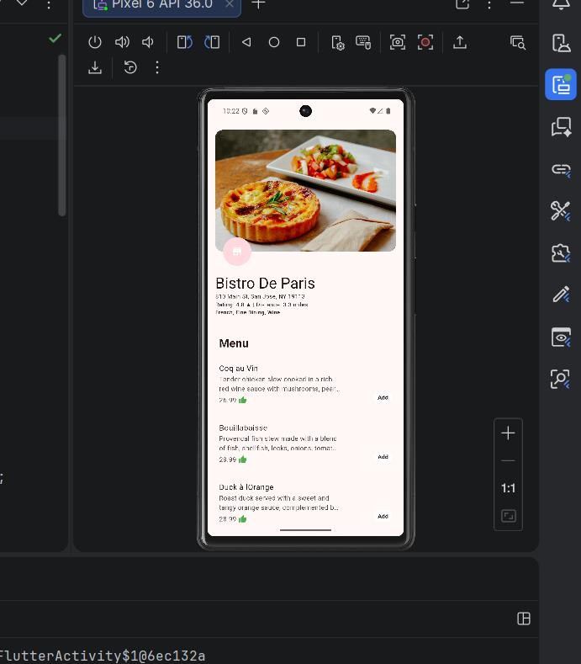
Next, I learned how to use Sliver widgets, which allow creating advanced scrolling effects. For example, I implemented a collapsible app bar, which changes its size while scrolling.
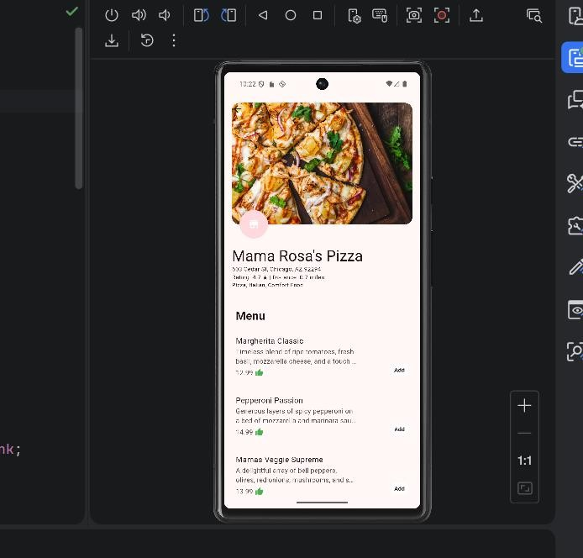
After that, I built the restaurant information section and used GridView to display menu items in a responsive layout. This helps the UI look good on different screen sizes.
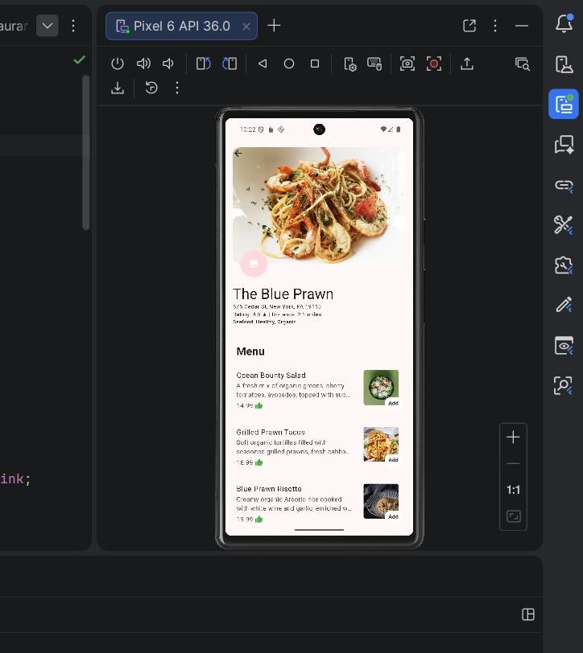
Finally, I made the page more adaptive for different devices, such as mobile and web, which improved the overall usability of the app.
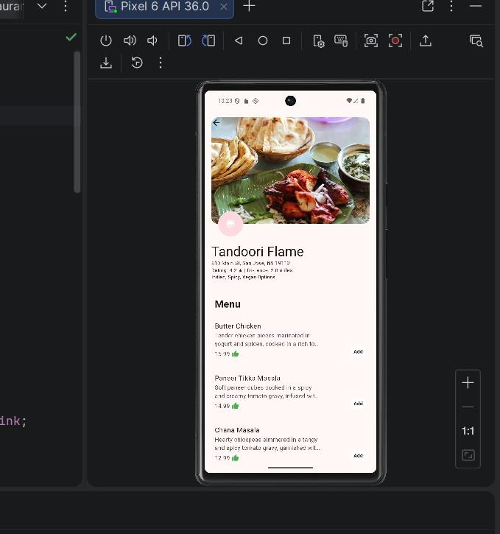

Conclusion
In Chapters 5 and 6, I learned how to build scrollable layouts and create more advanced and interactive UI screens in Flutter.
I gained practical experience with widgets like ListView, GridView, FutureBuilder, and Slivers, and learned how to organize content efficiently.
These chapters helped me better understand Flutter UI design and gave me the skills to create modern, responsive, and user-friendly application screens.

